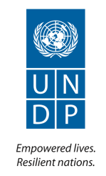

STRENGTHENED EARLY RECOVERY OPERATIONS AND COORDINATION
PROGRESS FINAL REPORT 2013
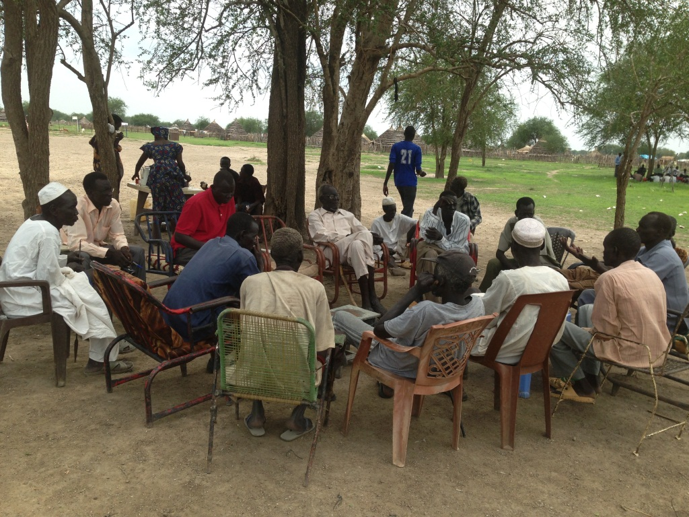

JCRP, Intra-community dialogue, Abyei, June 2013

Implementing Agency: | United Nations Development Programme (UNDP)
Country: | Sudan
Project Title and ID: | Strengthened Early Recovery Operations and Coordination (00072220)
Reporting Period: | August 2012 - June 2013
Total Contributed Amount: | USD150,000
Funds Available: | USD0.0
Contact Persons: | Pontus Ohrstedt (pontus.ohrstedt@undp.org), Head of the Crisis Prevention and Recovery Unit  Musa Ibrahim (musa.ibrahim@undp.org), Peace and Development Specialist

TABLE OF CONTENTS

EXECUTIVE SUMMARY 3
I. INTRODUCTION 3
1.1 Situation Analysis 3
1.2 CPR Capacity Support Strategy 4
II. PROGRESS REVIEW 5
III. CHALLENGES AND LESSONS LEARNED 8
IV. PARTNERSHIPS AND SUSTAINABILITY 8
4.1 Partnerships 8
4.2 Sustainability 9
V. FINANCIAL SUMMARY 9
Annex: CPR unit project activity location map 2012 10

EXECUTIVE SUMMARY

The additional contribution from the Bureau of Crisis Prevention and Recovery of US$ 150,000 to the project “Strengthened Early Recovery Operations and Coordination,” made in August 2012, was for the purpose of responding to the needs of UNDP’s capacity strengthening on strategic and programme for conflict prevention and peacebuilding. The contribution has supported two key positions in the Crisis Prevention and Recovery (CPR) Unit in UNDP Sudan: National Peace and Development Specialist and Peacebuilding and Social Cohesion Programme Specialist. The total contribution of the US$150,000 has contributed to strengthening UNDP’s CPR programmes in Sudan, particularly in supporting the areas of conflict analysis and conflict sensitive programming, peacebuilding and social cohesion. The following indicates the progresses achieved.

- UNDP was requested to provide overall support to the Darfur Regional Authority (DRA) to conduct the Darfur Joint Assessment Mission (DJAM), which was stipulated in Article 32 of the Doha Document for Peacebuilding in Darfur (DDPD) and identify the needs for economic recovery, development and poverty reduction in Darfur. UNDP played an instrumental role in leading the DJAM process and coordination between the different international and national stakeholders and partners.
- A Darfur Development Strategy (DDS) was produced and presented in the International Donor Conference for Reconstruction and Development in Darfur organised in Doha, Qatar during the period 7-8 April 2013. The total requirement of the DDS is US$7.245 billion for a period of 6 years 2013-2019. A total of US$1.039 billion was pledged during the Conference. Immediate cash of US$177.4 million is required to support the Foundational and Short Term Activities (FaST). A total support amounting US$88.5 million has been pledged by the State of Qatar out of their overall contribution of US$500 million, to support the FaST activities.
- The National Peace and Development Specialist (NPDS) provided the core technical capacity on peacebuilding and conflict sensitive planning and programming to CPR Unit but also to the CO in general. This includes contribution to the UNDAF and CPAP processes by ensuring that proper conflict and political analysis is provided to the strategic planning processes to ensure relevance and effectiveness of the responses.
- NPDS provided sustainable and systematic technical and institutional capacity building support to the Darfur Regional Authority (DRA) to assist them in the follow up on implementation of the DDS continued.
- The NPDS continued providing technical and oversight support to JCRP and in areas of conflict and political analysis and conflict sensitive programming.
- Technical support in the areas of conflict analysis and conflict sensitive programming, identification of entry points, and development of project document was provided to the Darfur Community Recovery and Coexistence project (DCRC). A total funding of USD997,000 was received from Darfur Community Peace and Stability Fund (DCPSF) for phase I. Technical support still continuing to develop phase II of the project.
- Technical support on conflict analysis and conflict sensitive targeting of projects was provided to Darfur Community Peace and Stability Fund (DCPSF), CSAC and DDR programmes.
- The NPDS continued providing conflict and political economy analysis to the Senior Management and the CO in general.
- The political and conflict analysis progress are conducted for Darfur and the three areas (South Kordofan, Blue Nile and Abyei) to inform programming and update UNDP management and partners on the political and peacebuilding development in the region and assist in identification of programmatic entry points. A copy of the three areas conflict analysis attached.
- A representative of the Reconciliation and Peaceful Co-existence Mechanism (RPCM) in South Kordofan and Peace Council Mechanism (PCM) in the Blue Nile in a project board expressed their satisfaction of UNDP’s support to peacebuilding and capacity development of the RPCM and the PCM.
- UNDP has been asked to work as the sector lead for a newly established sector under the humanitarian coordination mechanism, i.e. Governance, Infrastructure and Economic Recovery (GIER) Sector.
- The 2013 GIER sector response plan included projects addressing early recovery type of activities (USD 42.3 million) linking between humanitarian assistance and development.
- UNDP CPR Unit has led three UNAMID-UNCT Joint Working Groups for implementation of the DDPD. The three working groups are (i) Recovery, Reconstruction, Livelihoods and Environment; (ii) Ceasefire, Monitoring and Security Arrangements; and (iii) Peacebuilding, Social Cohesion and Reconciliation.

INTRODUCTION

1.1 Situation Analysis

The conclusion of the Comprehensive Peace Agreement (CPA) and the independence of South Sudan on 9 July 2011, brought profound implications on the social, economic and political context in northern Sudan. The political, economic and social tensions have intensified especially along the new border with the South, as evidenced by the clashes between the Sudan Armed Forces (SAF) and the Sudan People’s Liberation Army (SPLA) in Heglig in April 2012 and later 2012, which significantly affected peacebuilding initiatives at the local level. The confrontation between the Sudan and South Sudan add complication to an already volatile internal political context. Not only the renewed clashes between SAF and SPLM North in South Kordofan and Blue Nile, but also in Darfur, the crisis could be exacerbated if the root causes of conflict are not addressed and damaged social fabric is not mended.

Local conflicts have been exacerbated by the tension around unresolved CPA issues (Abyei, citizenship, oil, borders, allocation of debt between North and South), spread of small arms and weak local governance/rule of law structures and national conflict resolution mechanisms are limited. Women remain disproportionally affected by local conflicts while their role in promoting peace is under-utilized.

The situation in Darfur remains complex. While the peace process gained new momentum in 2011 with the signing of the Doha Document for Peace in Darfur (DDPD) and the subsequent establishment of the Darfur Regional Authority. Continuous efforts are needed to ensure the peace process is inclusive and thus addresses all root-causes of the conflict in the region, promoting recovery and long term development.

1.2 CPR Capacity Support Strategy

BCPR has provided extensive support to the Sudan Country Office (CO) for the past four years to address the immense CPR-challenges in Sudan and South Sudan, helping to scale-up CPR programming in key geographic areas and on critical thematic issues, such as conflict analysis, DDR and conflict prevention / community security. As a result, both the current and new UNDP Country Programme Document (CPD) (2013-2016) for Sudan included a substantive CPR programme component.

The new situation in Sudan has directed the CPR programme in Sudan to re-focus attention to address root-causes of conflict and promote social cohesion, including natural resource management and governance deficits. This has been articulated in the draft UNDAF and CPD under two outcomes:

- Outcome 7: Government and civil society initiatives that promote social cohesion, peace consolidation and pluralism are strengthened.
- Outcome 8: Peace dividends are delivered for sustainable return, reintegration and recovery.

In light of the above, building on previous BCPR support, the CO has created two key positions to ensure that a top-level CPR programme is sustained in line with the request of UNDP’s national counterparts and responding to the needs of the Sudanese population:

- National Peace and Development Specialist (NOC): The post is expected to (1) provide in-depth analysis of the evolving political and social dynamics, (2) provide technical support to local peace initiatives and (3) provide support to conflict-sensitive programming and targeted peacebuilding interventions.

- Peacebuilding and Social Cohesion Programme Specialist (P3): The post manages and broadens UNDP’s conflict prevention and peacebuilding portfolio, by identifying new areas of intervention closely linked to other programme areas, particularly natural resource management, crisis governance and rule of law. The incumbent is expected to work closely with the national Peace and Development Specialist and promote joint programming with other UN agencies for stronger results and impact.

PROGRESS REVIEW
EXPECTED OUTPUTS AND INDICATORS | PLANNED ACTIVITIES | PLANNED BUDGET for 2012-2013 | EXPENSES | RESULTS OF ACTIVITIES | PROGRESS TOWARD ACHIEVING OUTPUTS
Strengthened impact of UNDP programmes in the area of peacebuilding, social cohesion, community security  Indicator: Delivery rate (annual expenses/ annual budget) of the CPR unit  Indicator: The level of confident in UNDP on peacebuilding and social cohesion programming by the Government and international community | Activity Result 1.1: Improved synergies among the CPR programmes and other focus areas with particular attention to crisis governance, rule of law and natural resource management  Action: Support to develop CPAP 2013-2016  Action: Promote coherency of UNDP’s approach in peacebuilding and conflict prevention of different projects | US$150,000 | US$150,000 | - A new CPAP was drafted in clarifying the link and synergies among projects and to the UNDAF outcomes. | - It is still premature to assess the level of impact of UNDP programmes in the areas of peacebuilding, social cohesion, and community security. However, the following indicate UNDP’s improved its visibility in Sudan the area of peacebuilding, social cohesion, community security.  - UNDP was requested to provide overall support to the Darfur Regional Authority (DRA) to conduct the DJAM  - The Darfur Development Strategy (DDS) finalised and produced in the agreed time frame  An International Donor Conference for Reconstruction and Development in Darfur organised in Doha, Qatar during the period 7-8 April 2013. A total of US$1.039 billion was pledged during the Conference  International community and donors expressed their financial and political commitment to supporting peacebuilding, stability, recovery and reconstruction processes in Darfur within the DDS and DDPD frameworks  - A representative of the Reconciliation and Peaceful Co-existence Mechanism (RPCM) in South Kordofan and the Peace Council Mechanism (PCM) in the Blue Nile in a project board expressed their satisfaction of UNDP’s support to peacebuilding and capacity development of the RPCM and PCM  - UNDP has been asked to provide support on early recovery to humanitarian assistance communities (both UN agencies and civil society organizations) linking between humanitarian assistance and development
 | Activity Result 1.2: Enhanced partnerships between UNDP and other UN agencies and joint programming promoted  Action: Support coordinating UN agencies, IFIs for the Darfur Joint Assessment Mission  Action: Support the UN Joint Programme for Conflict Prevention and Peacebuilding in Sudan  Action: Support coordinating the Doha Document for Peacebuilding for Darfur (DDPD) UN-UNAMID Joint Working Group on Peacebuilding and Social Cohesion  Action: Support promoting early recovery approach and leading a gap sector, Governance, Infrastructure and Economic Recovery Sector, under the Inter-Agency Standing Committee mechanism |  |  | - Partnership and “Joint”-ness of the International Community in supporting Implementation of the DDPD including peace and security has improved by agreeing on the results framework of DDPD implementation from short-term (24 months) to long-term (6 years)  - In particular, UNAMID and UN Agencies have identified joint initiatives in supporting the implementation of the DDPD including in the area of peacebuilding, social cohesion and reconciliation, which was co-led by UNAMID and UNDP.  - A Joint Programme among 6 UN agencies supported by MDG-F has completed by December 2012 and delivered results for peacebuilding regardless of the difficult situations in South Kordofan.  - UNDP has led a newly established Governance, Infrastructure and Economic Recovery (GIER) sector and contributed to the Humanitarian Work Plan 2013 in promoting an early recovery approach and identifying gaps in linking humanitarian assistance to development. The identified gap sector was led by UNDP and identified 27projects under the HWP 2013 in total of amount US$42.3 million.
 | Activity Result 1.3: National and local peace initiatives supported to restore social cohesion and resilience in Darfur, Abyei, Southern Kordofan and Blue Nile States  Action: Enhance capacity of State governments and civil society in Southern Kordofan, Blue Nile and Abyei to lead effective peace processes  Action: Identify flashpoint conflicts based on evidence and successfully mitigated through government-led peace processes  Action: Support sustainable government-led peace processes and agreements through coordinated interventions addressing root causes of conflict. |  |  | - Capacity building of the national and civil society has been supported particularly through the projects of “Joint Conflict Reduction Programme,” “Crisis Risk Mapping and Analysis,” “Darfur Community Peace and Stability Fund,", ”Darfur Community Recovery for Coexistence”, “Enhancing Livelihood Opportunities and Building Social Capital for New Livelihood Strategies in Darfur”  In total, the projects excluding DCPSF delivered more than US$17million in 2012.  - 64% of the community-level peace processes supported by the JCRP still sustain regardless of the wider political conflict situation in South Kordofan and Blue Nile states.
Total |  | US$150,000 | US$149,999.74

CHALLENGES AND LESSONS LEARNED

UNDP’s programme for peacebuilding, social cohesion and community securities consolidated its impact by tailoring and targeting grassroots peacebuilding based on respective causes of conflict and taking a community-based approach. The approach finds effective to strengthen social cohesion and thus increase resilience to local conflicts. One of the perception surveys conducted as a part of monitoring results of community-based peacebuilding supported by the Darfur Community Peace and Security Fund (DCPSF) indicated that 91 percent of the sampled people in Darfur responded that trust and confidence increased in the communities through such a bottom up approach.

In the context of the Sudan, the approach would need to be complimented by political and national level peacebuilding initiatives. However, UNDP has faced following challenges during the 2013 to strengthen CPR programmes for peacebuilding.

- No specific government counterpart on peacebuilding is identified at the national level.
- The Government does not appreciate soft component of peacebuilding projects. In Darfur Region the local authorities expressed their resistance to even conducting a peacebuilding training workshop at the community level.
- Breakout of the conflict made the political environment is hardly conducive to peacebuilding at the sub-national level.
- Particularly, the situation in South Kordofan, Blue Nile and Abyei has further deteriorated and (i) restricted access, (ii) politicization, (iii) limited space for peacebuilding were the constant problems.
- Limited space for civil society on peacebuilding. There is high sensitivity to see the civil society organizations engaged in support community peacebuilding programmes.

Capacities of implementing partners in the area of peacebuilding are generally weak and would need to be supported and strengthened to increase their outreach and effectiveness. This creates a great challenge in implementation of the activities at grassroots and community level.

One of the challenges is linking and enabling local stakeholders at grassroots and community level (micro level) to engage in relevant high-level peace processes and agenda (macro level). This is becoming critical since most of the local conflicts have a direct correlation with the macro political conflict. The project started engaging in diversification of partners at national and state level to start making this linkages and synergies.

PARTNERSHIPS AND SUSTAINABILITY

4.1 Partnerships

Partnership with multitude of stakeholders in Government and civil society, and with international organizations in peacebuilding represents the cornerstone of the delivery strategy of PCR programmes.

During the period under review, partnerships with national NGOs working in peacebuilding (particularly SUDIA, Hala Help and Peace and Development Studies Centre of Dilling University) were explored. Partnership with Concordis and AECOM has also continued since 2011.

A key area of focus in 2013 was establishment of partnership with academic institutions, mainly with Peace and Development Centers of Darfur Universities and Peace Research Institute of the University of Khartoum to get engaged in peacebuilding activities and to diversify partnership. Partnership with the academic institutions helped in creating a credible and trusted platform and space for community dialogue on peacebuilding and social cohesion issues. It also helped in expanding monitoring of some indicators and gathering baseline data for the M&E framework.

Close coordination with the Ministry of Finance and National Economy as a potential national partner at the Federal level and with Darfur Regional Authority (DRA) as a regional partner will be critical in this area and it will enhance the linkages between the local peace mechanisms and issues with the macro and high level peace processes.

By taking the lead role of the GIER sector under the humanitarian coordination mechanism, UNDP strengthened partnership with national and international NGOs and other UN agencies that are particularly addressing early recovery approach in their humanitarian and development works. There are some 40 partners in the GIER sectors and UNDP supported to strengthening their proposal development, monitoring and advocacy for the needs of early recovery.

4.2 Sustainability

In addition to strong partnerships, sustainability of interventions is central to the project strategy. Throughout the DJAM process, the DRA was a driving force and UNDP has supported DRA’s capacity development through providing technical expertise and on the job-training/couching. The National Peace and Development Specialist was seconded (50%) to provide technical support to DRA. This proved to be an effective and efficient approach in capacity development and technical support. It created trust and confidence between UNDP and DRA and UNDP is seen as a credible development and peacebuilding partner.

In other peacebuilding projects, it was a strategy to engage and develop local capacities for peacebuilding and conflict reconciliation. For example, JCRP looked at the possibility of engaging the main government counterparts in Southern Kordofan State (RPCM) and Blue Nile State (PC) to undertake direct management of a limited number of project activities. This strategy has two major immediate benefits: First is the process of engagement of the partners including an assessment of their capacity to manage the implementation of targeted activities. This process brings out key capacity gaps of the partners, providing an opportunity to incorporate such capacity challenges in project activities. The second benefit is that with restricted access to the project areas by project staff, delivering project inputs through local counterparts, if well managed, will enhance the quality and volume of programme delivery.

In addition to this strategy, the following sustainability strategies are also in place:

- A strong focus was placed on assessing the resilience of both government partners and peace processes supported to date given the current context, and efforts put in place to guarantee the realization of this target.
- More comprehensive training for governments, INGO and CBO/national NGO partners was a strong element of delivery to ensure all stakeholders are ready to intervene once hostilities cease and the environment more permissive to project implementation work.
- As part of promoting sustainability, partnership established with academic institutions specialized in the areas of peacebuilding to create a credible and trusted platform for dialogue, help in monitoring some of the indicators and gathering baseline information for the M&E framework. Further it will ensure that knowledge on emerging trends in, and tools, for conflict management and peacebuilding is created and retained at national and regional level.

FINANCIAL SUMMARY

Donor | Opening Balance 2012 | Allocations 2012-2013 | Total Expenses in 2012-2013 | Remaining Balance
CPR TTF  (Fund Code: 26900; Donor Code: 00555) | US$150,000 | US$75,000 | US$149,999.74 | US$0.26

(ATLAS CDR for 2012 and 2013 attached)

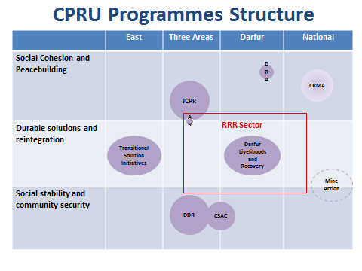

CPRU Projects in 2013

